Experiment 1.3

**Aim:** *Design LCD interfacing on WOKWI or TinkerCad Simulation Platform.*

# Objectives:

*1. Learn about IoT based simulations.*

*2. Testing and model in IoT based simulation platform*

**Hardware and Software:**

*1. Workwi*

*2. Connecting Cable*

*3. Arduino uno*

# Description:

*Arduino Board: Arduino boards are open-source microcontrollers used for creating electronic projects. They have digital and analog pins for connecting sensors and devices. You program them using the Arduino IDE and the C++ language*

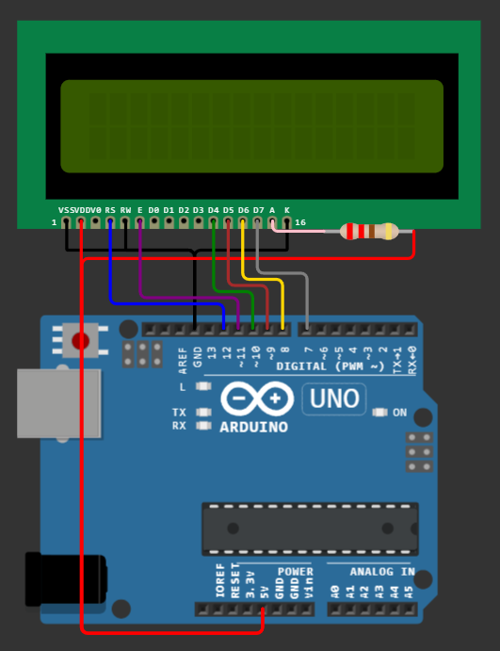

# Code:

# *#include <LiquidCrystal.h>*

# *LiquidCrystal lcd(12, 11, 10, 9, 8, 7);*

# *void setup() {*

# *lcd.begin(16, 2);*

# *}*

# *void loop() {*

# *lcd.print("Hello");*

# *delay(1000);*

# *lcd.clear();*

# 

# *lcd.print("Myself SANJIV");*

# *delay(1000);*

# *lcd.clear();*

# 

# *lcd.print("UID: 21BCS3478");*

# *delay(1000);*

# *lcd.clear();*

# *}*

# Output:

# 

# Learning Outcomes:

1. *Use of sensors.*
2. *Learn to perform task on another platform*